Probability summary

- The normal distribution

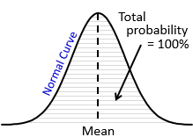
- It is represented by a bell-curve
- The mean is centred with most data clustered around it
- The bell-curve is symmetrical
- A normal distribution is unbounded (there is no limit to where it starts or ends)
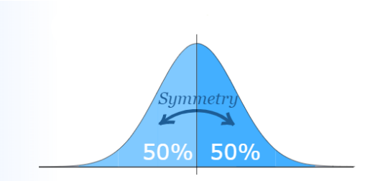
- The area under the line represents the total probability and equals 1 (100%)
- The standard deviation measures the spread of the distribution
- Nearly all values lie within three standard deviations on either side of the mean

- The standard normal distribution

The Z-score measures the number of standard deviations to the right or left of the mean.
Remember:
- A negative Z-score lies to the left of the mean.
- A positive Z-score lies to the right of the mean.
- The formula to find the Z-score will be given in the assessment, but you must memorise what the symbols mean:
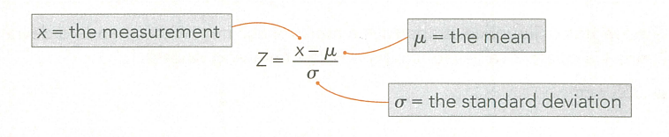
Z-score
Read down first and then across.

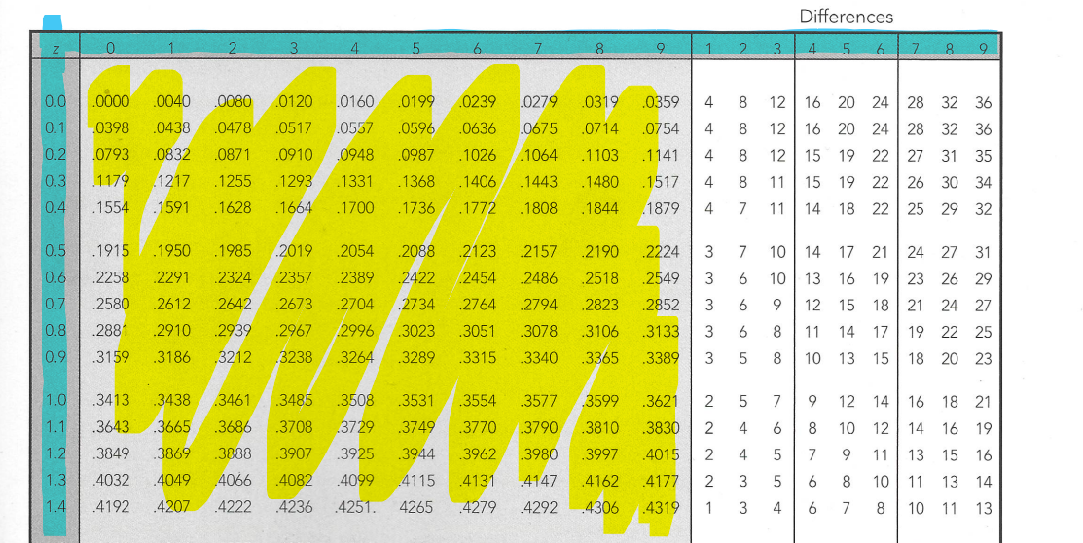
Differences:
Add these on to the probabilities when using the Z-score to find probabilities.
Probabilities

- Other shapes of graphs:

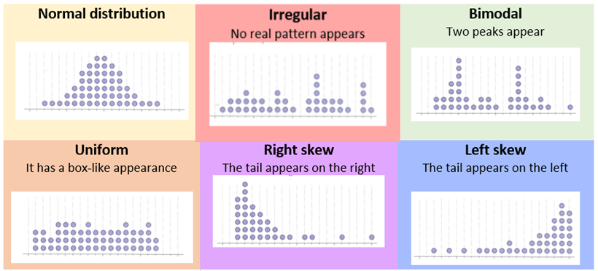

- Two-way frequency tables
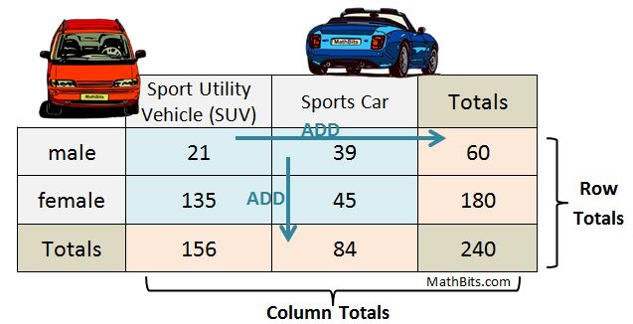

- Calculations
Remember:
- “and” means times ($×$)
- “or” means adds (+)

- Probabilities can be expressed as fractions, decimals, or percentages.
The formula to find a probability as a fraction is:
$$Probability= \frac{number of favourable outcomes}{total possible outcomes}$$
For example: What is the probability of rolling 5 with a dice?
Number of favourable outcomes: There is only one 5 on a dice = 1
Total possible outcomes: A dice has six sides = 6
$$P\left(5\right)=\frac{1}{6}$$

- Finding the expected number: $probability of event ×number of trails$
For example:
A dice is rolled 50 times. How many times would you expect it to land on 3?
The probability of the event (landing on 3) is: $\frac{1}{6}$
The number of trails is 50 times.
Calculation: $\frac{1}{6} ×50=8.333… ≈8 times$

- Risk
Absolute risk is the probability of something bad happening.
Relative risk is the probability of one event divided by the probability of a second event occurring:
$$\frac{Absolute risk of event A}{Absolute risk of event B}$$
For example:
According to NHTSA the probability of being in a car accident in an urban area is 53% and in a rural area is 45%. How many times as likely is it to be in a car crash in an urban area than a rural area?
$$\frac{0.53}{0.45}=1.1778 (4 d.p.)$$
This means that you are 1.1778 times as likely to be in a car crash in an urban area than a rural area, or 0.1778 (1.1778 – 1) more likely.

- Probability trees:
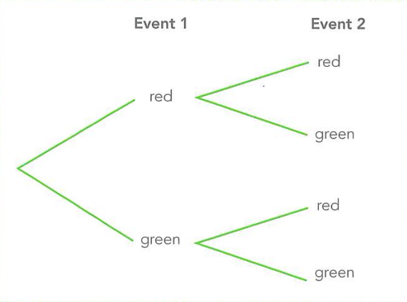
Each group should add to 1.

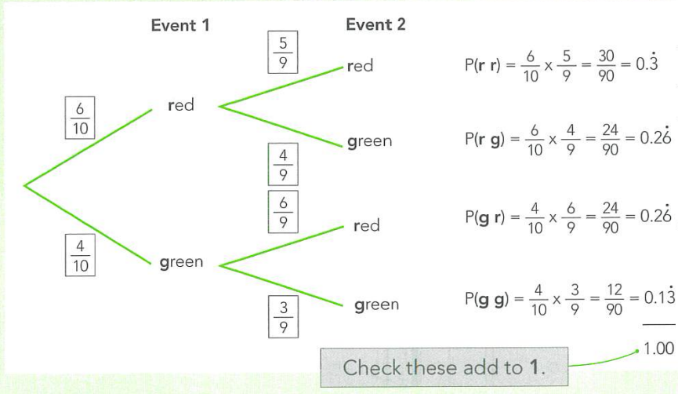
Overall outcomes:
Multiply the probability of each branch together.

